**COFFEE SHOP SALES DASHBOARD QUERIES**

1. Total Sales for a specific month

SELECT ROUND(SUM(unit_price * transaction_qty)) as Total_Sales

FROM coffee_shop_sales

WHERE EXTRACT(MONTH FROM transaction_date) = 5; -- for month of May

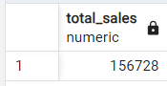

1. Total Sales Difference and MOM growth

WITH monthly_sales AS (

SELECT

EXTRACT(MONTH FROM transaction_date) AS month,

ROUND(SUM(unit_price * transaction_qty)) AS total_sales

FROM

coffee_shop_sales

WHERE

EXTRACT(MONTH FROM transaction_date) IN (4, 5) -- for months of April and May

GROUP BY

EXTRACT(MONTH FROM transaction_date)

ORDER BY

EXTRACT(MONTH FROM transaction_date)

)

SELECT

month,

total_sales,

(total_sales - LAG(total_sales) OVER (ORDER BY month)) /

LAG(total_sales) OVER (ORDER BY month) * 100 AS mom_increase_percentage

FROM

monthly_sales;

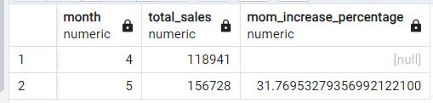

1. Total orders for a specific month

SELECT COUNT(transaction_id) as Total_Orders

FROM coffee_shop_sales

WHERE EXTRACT(MONTH FROM transaction_date) = 5; -- for month of May

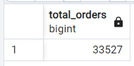

1. Total Orders Difference and MOM growth

WITH monthly_orders AS (

SELECT

EXTRACT(MONTH FROM transaction_date) AS month,

COUNT(transaction_id) AS total_orders

FROM

coffee_shop_sales

WHERE

EXTRACT(MONTH FROM transaction_date) IN (4, 5) -- for April and May

GROUP BY

EXTRACT(MONTH FROM transaction_date)

ORDER BY

EXTRACT(MONTH FROM transaction_date)

)

SELECT

month,

total_orders,

CASE

WHEN LAG(total_orders) OVER (ORDER BY month) <> 0 THEN

ROUND((total_orders - LAG(total_orders) OVER (ORDER BY month))::NUMERIC /

LAG(total_orders) OVER (ORDER BY month) * 100, 2)

ELSE

NULL

END AS mom_increase_percentage

FROM

monthly_orders;

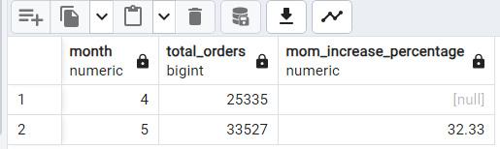

1. Total Quantity Sold for a month

SELECT SUM(transaction_qty) as Total_Quantity_Sold

FROM coffee_shop_sales

WHERE EXTRACT(MONTH FROM transaction_date) = 5; -- for month of May

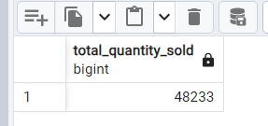

1. Total Quantity sold Difference and MOM growth

WITH monthly_orders AS (

SELECT

EXTRACT(MONTH FROM transaction_date) AS month,

SUM(transaction_qty) AS total_orders

FROM

coffee_shop_sales

WHERE

EXTRACT(MONTH FROM transaction_date) IN (4, 5) -- for April and May

GROUP BY

EXTRACT(MONTH FROM transaction_date)

ORDER BY

EXTRACT(MONTH FROM transaction_date)

)

SELECT

month,

total_orders,

CASE

WHEN LAG(total_orders) OVER (ORDER BY month) <> 0 THEN

ROUND((total_orders - LAG(total_orders) OVER (ORDER BY month))::NUMERIC /

LAG(total_orders) OVER (ORDER BY month) * 100, 2)

ELSE

NULL

END AS mom_increase_percentage

FROM

monthly_orders;

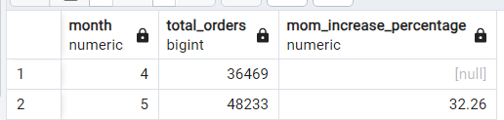

1. Day wise total sales, total quantity sold, total orders

SELECT

SUM(unit_price * transaction_qty) AS total_sales,

SUM(transaction_qty) AS total_quantity_sold,

COUNT(transaction_id) AS total_orders

FROM

coffee_shop_sales

WHERE

transaction_date = '2023-05-18'; -- For 18 May 2023

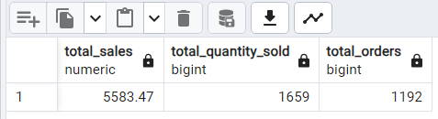

1. Dailly sales month wise

SELECT

EXTRACT(DAY FROM transaction_date) AS day_of_month,

ROUND(SUM(unit_price * transaction_qty), 1) AS total_sales

FROM

coffee_shop_sales

WHERE

EXTRACT(MONTH FROM transaction_date) = 5 -- Filter for May

GROUP BY

EXTRACT(DAY FROM transaction_date)

ORDER BY

EXTRACT(DAY FROM transaction_date);

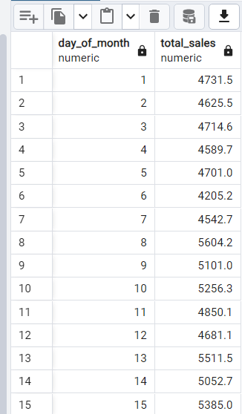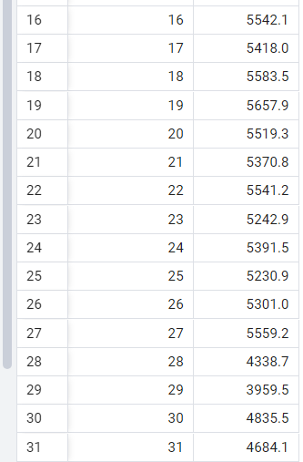

1. Daily avg Sales is below / above average

SELECT

day_of_month,

CASE

WHEN total_sales > avg_sales THEN 'Above Average'

WHEN total_sales < avg_sales THEN 'Below Average'

ELSE 'Average'

END AS sales_status,

total_sales

FROM (

SELECT

EXTRACT(DAY FROM transaction_date) AS day_of_month,

SUM(unit_price * transaction_qty) AS total_sales,

AVG(SUM(unit_price * transaction_qty)) OVER () AS avg_sales

FROM

coffee_shop_sales

WHERE

EXTRACT(MONTH FROM transaction_date) = 5 -- Filter for May

GROUP BY

EXTRACT(DAY FROM transaction_date)

) AS sales_data

ORDER BY

day_of_month;

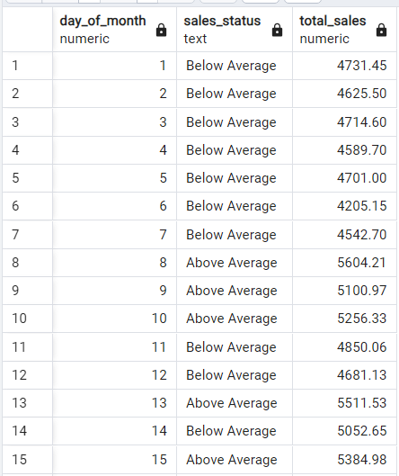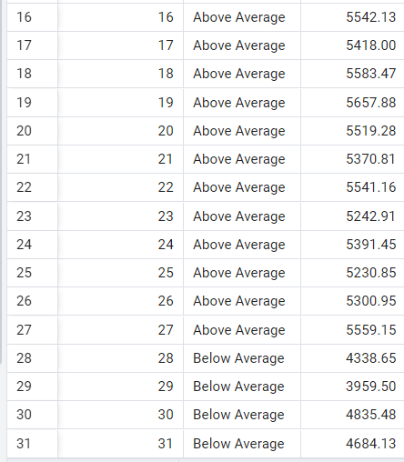

1. Sales by weekdays / weekends

SELECT

CASE

WHEN EXTRACT(DOW FROM transaction_date) IN (0, 6) THEN 'Weekends'

ELSE 'Weekdays'

END AS day_type,

ROUND(SUM(unit_price * transaction_qty), 2) AS total_sales

FROM

coffee_shop_sales

WHERE

EXTRACT(MONTH FROM transaction_date) = 5 -- Filter for May

GROUP BY

CASE

WHEN EXTRACT(DOW FROM transaction_date) IN (0, 6) THEN 'Weekends'

ELSE 'Weekdays'

END;

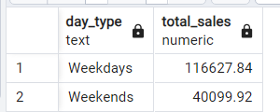

1. Sales by store location

SELECT

store_location,

SUM(unit_price * transaction_qty) AS total_sales

FROM

coffee_shop_sales

WHERE

EXTRACT(MONTH FROM transaction_date) = 5 -- Filter for May

GROUP BY

store_location

ORDER BY

SUM(unit_price * transaction_qty) DESC;

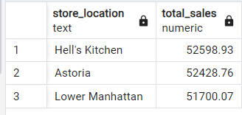

1. Sales by Product Category

SELECT

product_category,

ROUND(SUM(unit_price * transaction_qty), 1) AS total_sales

FROM

coffee_shop_sales

WHERE

EXTRACT(MONTH FROM transaction_date) = 5 -- Filter for May

GROUP BY

product_category

ORDER BY

SUM(unit_price * transaction_qty) DESC;

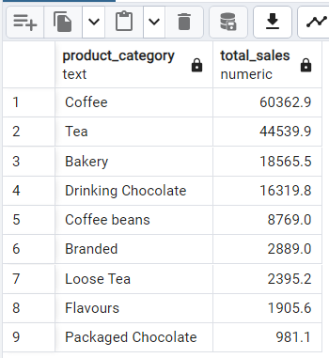

1. Sales by top products (top 10)

SELECT

product_type,

ROUND(SUM(unit_price * transaction_qty), 1) AS total_sales

FROM

coffee_shop_sales

WHERE

EXTRACT(MONTH FROM transaction_date) = 5 -- Filter for May

GROUP BY

product_type

ORDER BY

SUM(unit_price * transaction_qty) DESC

LIMIT 10;

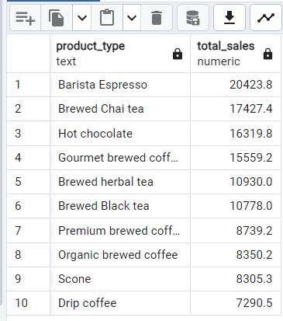

1. Sales by Day / hour

SELECT

ROUND(SUM(unit_price * transaction_qty)) AS total_sales,

SUM(transaction_qty) AS total_quantity,

COUNT(*) AS total_orders

FROM

coffee_shop_sales

WHERE

EXTRACT(DOW FROM transaction_date) = 2 -- Filter for Tuesday (0 is Sunday, 1 is Monday, ..., 6 is Saturday)

AND EXTRACT(HOUR FROM transaction_time) = 8 -- Filter for hour number 8

AND EXTRACT(MONTH FROM transaction_date) = 5; -- Filter for May (month number 5)

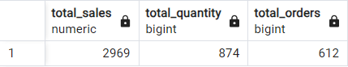

1. Day wise sales

SELECT

CASE

WHEN EXTRACT(DOW FROM transaction_date) = 1 THEN 'Monday'

WHEN EXTRACT(DOW FROM transaction_date) = 2 THEN 'Tuesday'

WHEN EXTRACT(DOW FROM transaction_date) = 3 THEN 'Wednesday'

WHEN EXTRACT(DOW FROM transaction_date) = 4 THEN 'Thursday'

WHEN EXTRACT(DOW FROM transaction_date) = 5 THEN 'Friday'

WHEN EXTRACT(DOW FROM transaction_date) = 6 THEN 'Saturday'

ELSE 'Sunday'

END AS day_of_week,

ROUND(SUM(unit_price * transaction_qty)) AS total_sales

FROM

coffee_shop_sales

WHERE

EXTRACT(MONTH FROM transaction_date) = 5 -- Filter for May

GROUP BY

EXTRACT(DOW FROM transaction_date) -- Group by the day of the week

ORDER BY

EXTRACT(DOW FROM transaction_date);

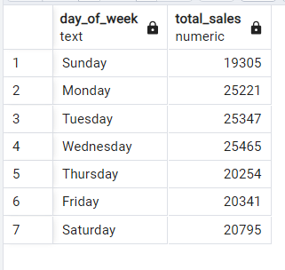

1. Hour wise sales

SELECT

EXTRACT(HOUR FROM transaction_time) AS hour_of_day,

ROUND(SUM(unit_price * transaction_qty)) AS total_sales

FROM

coffee_shop_sales

WHERE

EXTRACT(MONTH FROM transaction_date) = 5 -- Filter for May

GROUP BY

EXTRACT(HOUR FROM transaction_time)

ORDER BY

EXTRACT(HOUR FROM transaction_time);

